DEVELOPMENT OF EVENT MANAGEMENT SYSTEM FOR DEPARTMENT OF INFORMATION TECHNOLOGY IN CAVITE STATE UNIVERSITY – MAIN CAMPUS

Student Internship Report
Submitted to the faculty of the
College of Engineering and Information Technology
Cavite State University
Indang, Cavite

In partial fulfillment
of the requirements for the degree
Bachelor of Science in Information Technology

STEVEN CLYDE E. MARANAN
MARK VINCENT C. ASIBOR
GABRIEL IAN B. DE LEON
June 2026
INTRODUCTION
Overview
The purpose of this document is to define the functional and non-functional requirements of the Event Management System (EMS). This document serves as a reference for developers, project stakeholders, faculty users, and system administrators to understand system behavior, constraints, and expectations of the system. The Event Management System is designed to streamline the process of organizing, announcing, and tracking academic events and activities, reducing reliance on physical invitations. The system provides a centralized calendar dashboard that allows faculty members to schedule events, monitor timelines, and manage participation efficiently.
Scope
The Event Management System enables faculty hosts to notify specific departments or individual members through a digital invitation system. Event organizers may attach supporting images or documents such as official letters to serve as formal proof of attendance requirements. This digital workflow improves communication, accountability, and accessibility across the institution. The system is composed of three primary modules designed to support user authentication, event management, and scheduling workflows. These modules work together to provide an integrated platform for organizing and managing institutional events.
The Accounts Module manages all user authentication and identity-related processes within the system. This module is responsible for user registration, login, session management, and account validation. All user credentials and profile information are securely stored in the system database. It also serves as the central reference point for identifying faculty members when events are created or invitations are issued.
The Login/Register Sub-Module handle the processes of logging in existing users, registering new accounts, and managing forgotten passwords. The login function verifies user credentials and grants access to the system. The register function allows new users to create an account with validated information. The forgot password function enables users to securely reset their credentials if lost, ensuring continuous access to the system.
The Dashboard Account Sub-Module manages user interactions within the dashboard related to personal account and event participation. The Edit Dashboard function allows users to customize their dashboard view and personal settings, while the Accept/Decline Invites function enables users to respond to event invitations efficiently.
The Dashboard Module provides the primary user interface for viewing and managing scheduled events. It includes a calendar-based navigation system that displays upcoming invitations, hosted events, and scheduled activities in an organized format. Users may view events associated with their accounts, while event hosts are granted permissions to edit their own events directly from the dashboard. The module also allows quick access to event creation features.
The Create Event Module enables users to organize and publish events within the system. Hosts can define event details such as title, schedule, description, and participating departments. This module integrates with the Accounts Module to retrieve and display registered faculty members, allowing hosts to invite participants from their own department or other departments. The system supports attaching image files to serve as supporting documentation or proof related to the event, such as formal invitation letters or administrative approvals.
The Brevo API Module handles communication with external email services to send notifications and event invitations to users. It ensures that all messages related to event creation, updates, and reminders are delivered reliably. The module interacts with the Internet and the system’s Database to retrieve recipient information and track email delivery status. It plays a crucial role in keeping participants informed and engaged in events.
The Database Module serves as the central repository for all system data, including user accounts, event details, invitations, and attachments. It ensures secure storage, retrieval, and modification of data for all modules within the Event Management System. All interactions between the Account, Dashboard, and Create Event modules are synchronized through the database, maintaining data consistency, integrity, and availability. Backup and recovery mechanisms are also managed through this module to prevent data loss.
Context Diagram
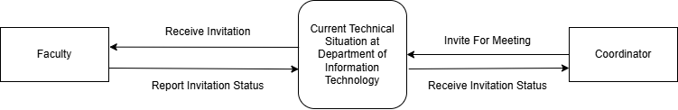

Figure 1. Context Diagram of the Current Technical Situation of Department of Information Technology

The diagram represents the Context Diagram of the Event Management System for the Department of Information Technology. It illustrates how external entities interact with the system and defines the system’s operational boundary.
Currently, the invitation process is conducted primarily through email communication. The coordinator sends invitations either individually or through group messages to faculty members regarding upcoming meetings or events. However, this process does not provide visibility into each faculty member’s regular teaching schedule or workload. As a result, invitations may conflict with existing classes or prior commitments, leading to scheduling issues, delayed responses, or reduced participation.
The proposed Event Management System addresses these limitations by centralizing event scheduling, invitation distribution, and response tracking within a unified platform, thereby improving coordination, transparency, and overall efficiency in departmental event management.
Use Case Diagram
The use case diagrams served as a guide to the development of the Event Management System, ensuring that the application’s functionality was clear, organized, and aligned with user needs. These diagrams were used throughout the design and development process to visualize interactions between users and the system, helping to ensure that all tasks could be performed efficiently and intuitively by the intended actors.

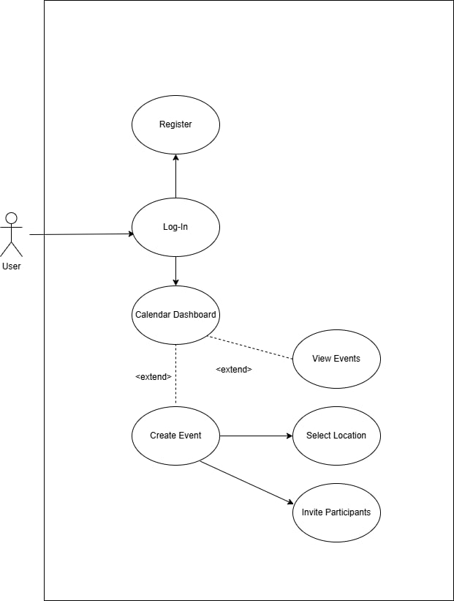

Figure 2. Use case diagram of entire interface
This diagram presents an overview of all major functionalities of the Event Management System and the interactions between various user roles, including faculty members, administrators, and students. It highlights the system’s primary use cases, such as managing events, sending invitations, and viewing schedules.

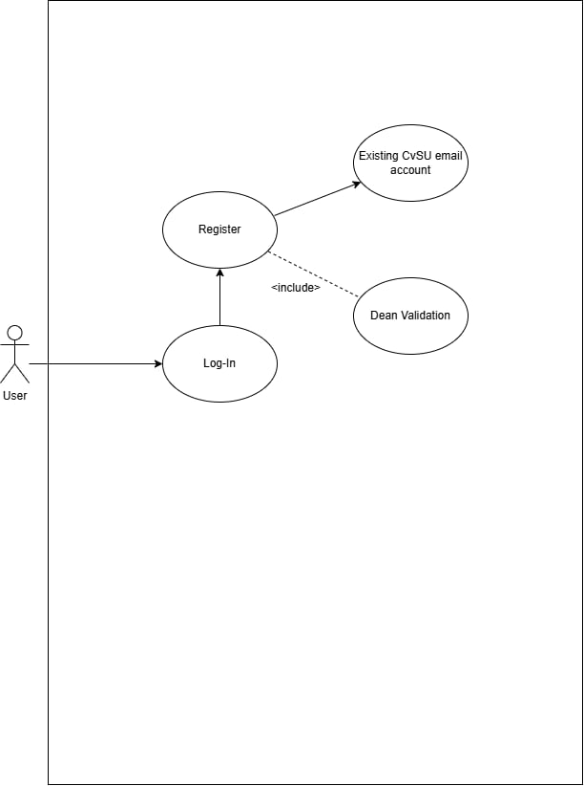

Figure 3. Use case diagram of Login interface
This diagram focuses on the login process, showing the interactions between users and the authentication module. It includes activities such as entering credentials, verifying identity, and handling failed login attempts, ensuring secure access to the system.

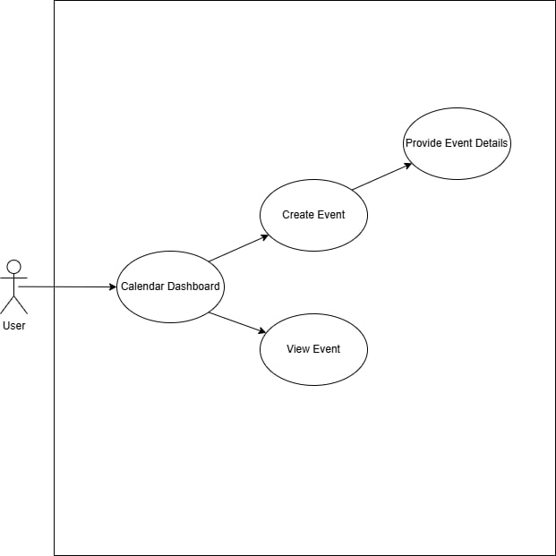

Figure 4. Use case diagram of Dashboard interface
This diagram illustrates how users interact with the dashboard after logging in. It captures key functions such as viewing upcoming events, tracking participation status, and accessing notifications, providing a central hub for managing event-related information.

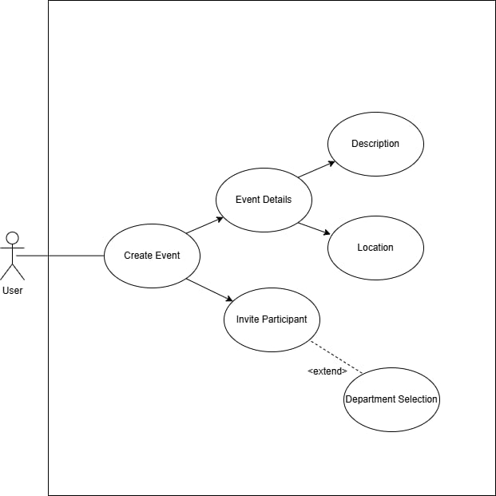

Figure 5. Use case diagram of Create Event interface
This diagram details the process of creating a new event within the system. It depicts interactions for entering event details, attaching supporting documents, setting dates and times, and notifying participants, highlighting the steps required for event management from initiation to confirmation.

Wireframes
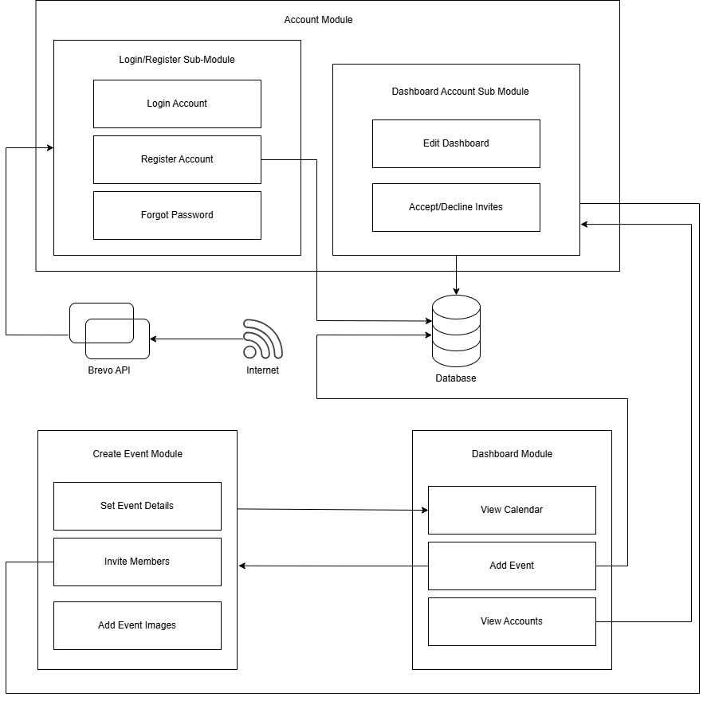
The wireframes served as a visual guide to the layout and interface design of the Event Management System, ensuring that the application was intuitive, consistent, and user-friendly. These wireframes were used throughout the development process to plan the placement of elements, navigation flow, and interactions, helping developers and stakeholders visualize the final system before implementation.
Figure 6. Wireframe Diagram of the entire system.
This diagram illustrates the main modules of the Event Management System, their sub-modules, and the interactions between them, including the database and external services (like the Brevo API and the Internet). It highlights how account management, event creation, and the dashboard work together to provide a seamless user experience.
Definitions and Acronyms
Brevo API - provides programmatic access to all platform features through a unified REST interface.
Dashboard – A dashboard is a visual interface that displays metrics and data in a single view.
Database - is a structured collection of data designed for efficient storage, retrieval and manipulation.
Event Host - An event host is an individual responsible for overseeing and managing the various aspects of an event.
Participant – are individuals who are actively involved in the event, contributing to discussions, activities, or workshops.
XAMPP – allows you to easily create a local web server on Windows, Linux and MacOS.

GENERAL DESCRIPTION
Purpose and Description
The project aims to address the inefficiencies in managing academic events and invitations within the Department of Information Technology by developing a centralized web-based Event Management System. The system improves coordination, enhances communication transparency, and reduces scheduling conflicts among faculty members.
The project has the following capabilities:
- Provide user registration and authentication within a secure web application. The system allows faculty members to create accounts and securely log in using verified credentials. This ensures that only authorized users can access event-related information and system features.
- Enable event creation and publishing through a structured digital platform. Authorized users (event hosts or coordinators) can define event details such as title, description, date, time, and participating departments. Once finalized, events can be published and made visible to invited participants.
- Ensure secure data storage and session management. The system securely stores user credentials, event records, and uploaded documents in a protected database environment. It maintains active sessions for authenticated users and implements proper logout and session expiration mechanisms to protect sensitive information.
- Implement a department-based invitation system. The system allows hosts to invite specific departments or selected faculty members. This improves targeting of invitations and ensures proper dissemination of event information without relying on manual email distribution.
- Provide a calendar-based dashboard for event monitoring and scheduling. The system displays upcoming events, invitations, and hosted activities in an organized calendar interface. This feature helps users visualize schedules and minimize conflicts with existing commitments.
- Support image and document attachment for events. Event organizers may upload supporting files such as official letters, memoranda, or approval documents. These attachments serve as formal proof of event legitimacy and attendance requirements.
- Allow event editing for authorized event hosts only. The system restricts editing privileges to the original event creator or authorized personnel. This ensures accountability and prevents unauthorized modification of event details.
These capabilities serve as a digital solution for improving academic event coordination within the Department of Information Technology. By utilizing a centralized web-based platform, event scheduling and invitation management become more efficient, accessible, and transparent for faculty members and coordinators. The system primarily benefits faculty and administrative personnel by enhancing communication workflows and reducing reliance on manual email-based processes.
User Characteristics
The Event Management System consists of three primary user roles, each assigned specific privileges and levels of interaction within the platform: System Administrator, Event Host, and Faculty Member. These roles are designed to ensure proper access control, accountability, and efficient management of system operations.

User Type | Description | Privilege Level
Faculty Member | Creates or participates in events | Basic to Intermediate
Event Host | Faculty assigned to create/manage events | Intermediate
System Administrator | Maintains system configuration | Advanced
Table 1. User Characteristic Table.

The System Administrator holds the highest level of authority within the system. This role is responsible for managing user accounts, maintaining system configurations, monitoring data integrity, and overseeing overall system functionality.
The Event Host is authorized to create, publish, edit, and manage events. Event Hosts can send invitations to selected departments or faculty members, upload supporting documents, and monitor participant responses through the dashboard.
The Faculty Member serves as a participant within the system. Faculty Members can view invitations, access event details, respond to invitations, and monitor their scheduled events through the calendar-based dashboard.
This role-based structure ensures that users can only access features relevant to their responsibilities, thereby maintaining system security, organization, and operational efficiency.

GENERAL CONSTRAINTS
Software Constraints
The Event Management System operates within a defined software environment to ensure stability, compatibility, and maintainability. The following software constraints apply:
- Backend must run on XAMPP (Apache + PHP 8.2+) and Brevo API
- Database must be MySQL (Port 3306)
- Frontend must be compatible with modern browsers (Chrome, Edge, Firefox)
- Backend framework: Laravel PHP Framework
- Frontend development: React – Vite – Tailwind
These software constraints define the technical environment required for system development, deployment, and maintenance.
Hardware Constraints
The Event Management System is designed as a web-based application and therefore has minimal hardware requirements. However, the following constraints must be met:
- Must run on standard desktop or mobile devices
- Requires internet connection
These constraints ensure that the system functions efficiently while remaining accessible across commonly available devices within the institution.

ASSUMPTIONS AND DEPENDENCIES
Assumptions
The development and operation of the Event Management System are based on the following assumptions:
- Faculty members are assumed to possess valid institutional accounts and authorized access credentials. These accounts serve as the basis for user registration and identity verification within the system.
- It is assumed that users have access to a stable and reliable internet connection. Since the system operates as a web-based platform, uninterrupted connectivity is necessary to ensure proper access to dashboards, event information, and invitation responses.
- Users are expected to access the system using supported and updated web browsers. Compatibility with modern browsers ensures proper rendering of the user interface and smooth system interaction.
- Furthermore, it is assumed that users have basic knowledge of web navigation, including logging in, viewing calendar schedules, and interacting with digital forms.
Dependencies
The Event Management System relies on several technical components and development tools to function correctly. These dependencies are essential for system deployment, execution, and maintenance.

- The system depends on the XAMPP environment, which provides the Apache web server and PHP runtime necessary for backend processing.
- The system depends on Brevo API, which is used for email verification and account retrieval on login.
- The backend application is dependent on the Laravel Framework, which manages routing, authentication, business logic, and database communication.
- The frontend build and development process depends on the Vite Development Server, which handles asset compilation and improves development efficiency.
- The system also depends on the MySQL Database Management System for secure storage and retrieval of user accounts, event records, invitations, and uploaded files.
- The system depends also on Brevo API on handling email verifications and forgot password’s implementation.
- Finally, the system requires access through a modern web browser to ensure proper display and functionality of the web-based interface.
These dependencies collectively define the technical foundation required for the proper operation of the Event Management System.
Platform
The system is a web-based application designed to be accessible on both desktop and mobile devices.

FUNCTIONAL REQUIREMENTS
This section presents the complete list of functional requirements of the Event Management System. Each requirement defines a specific behavior or capability the system must perform.
Module | Description
Accounts | 1. The system shall allow faculty members to register an account using authorized credentials.  2. The system shall authenticate users through a secure login mechanism.  3. The system shall maintain user session management to prevent unauthorized access.  4. The system shall store and manage user profile information in a secure database.  5. The system shall associate each registered user with their respective department.  6. The system shall restrict access to system features based on user permissions.
Dashboard | 1. The system shall provide a dashboard that displays upcoming events in a calendar format.  2. The system shall allow users to view events associated with their account.  3. The system shall categorize events into hosted events, invitations, and scheduled activities.  4. The system shall allow event hosts to edit events they created.  5. The system shall update dashboard information in real time after event changes.
Create Event | 1. The system shall allow authorized users to create new events.  2. The system shall require event details including title, description, schedule, and participants.  3. The system shall allow hosts to invite faculty members or departments to an event.  4. The system shall enable hosts to edit or cancel events prior to the scheduled date.  5. The system shall validate event schedules to prevent conflicts or invalid entries.
Brevo API | 1. The system shall use Brevo API to send email verification links to new users upon registration.  2. The system shall require the user’s email address to send verification or password reset emails.  3. The system shall allow users to request a password reset email via the Brevo service.
Database | 1. The system shall store all event, user, and notification data securely in the database.  2. The system shall maintain relational integrity between events, participants, and notifications.  3. The system shall allow authorized users to query and retrieve records efficiently.  4. The system shall support create, read, update, and delete (CRUD) operations for events, users, and notifications.  5. The system shall validate all database inputs to prevent invalid or duplicate entries.
Table 2. Functional Requirements of the system.

EXTERNAL INTERFACE REQUIREMENT
User Interface
The system shall provide a responsive web interface accessible on desktop and mobile devices.
Interface components include:
- Login and Registration Forms
- Calendar Dashboard
- Event Creation Form
- Invitation Response Interface
- Administrative Management Panel
The UI shall follow consistent layout design and usability standards.
Data Interface
The system shall interact with:
- MySQL Database for persistent data storage
- Laravel backend APIs for business logic processing
- File storage system for attachments
All database communication shall follow secure query handling to prevent SQL injection.
Other Interfaces
- Web Browser Interface (Chrome, Edge, Firefox)
- Local development servers (Apache, Laravel Artisan & Vite)
NON-FUNCTIONAL REQUIREMENT
The non-functional requirements serve as guiding principles in the development of the Event Management System, ensuring that the application is secure, reliable, efficient, and accessible to all authorized users. These requirements define the overall quality standards of the system rather than specific functional behaviors.
Table 3 presents the non-functional requirements of the system, outlining the operational capabilities and quality attributes necessary to meet institutional standards and user expectations.
MAIN FUNCTION(S) | DETAILED REQUIREMENTS / DESCRIPTION(S)
Performance Efficiency | The system shall load dashboard pages, event details, and invitation lists within a reasonable timeframe under normal network conditions.
Interaction Capability | The system shall allow users to easily navigate between dates and view scheduled activities. The system shall also provide immediate feedback for user actions, such as confirmation messages after event creation or status updates after responding to invitations.
Security | The system shall ensure that only authorized users can access sensitive information, such as event details, participant lists, and institutional data.
Reliability | The system shall maintain stable performance with minimal downtime, ensuring continuous availability of the dashboard, event management, and notification features.
Table 3. Non-Functional requirements of the system

REFERENCES
Attendees vs. participants - what’s the difference? This vs. That. (n.d.). https://thisvsthat.io/attendees-vs-participants
GeeksforGeeks. (2025, September 10). What is database? https://www.geeksforgeeks.org/dbms/what-is-database/
Overview. Brevo API Documentation. (n.d.). https://developers.brevo.com/docs/getting-started
TecnoDigital. (2025, June 19). What is XAMPP? features, installation, and detailed use in 2024. Informática y Tecnología Digital. https://informatecdigital.com/en/What-is-XAMPP/
Refine. (2026, February 9) What is a dashboard? The Complete Guide for 2026:. https://refine.dev/blog/what-is-a-dashboard

